**EMPLOYEE ATTENDANCE MONITORING SYSTEM**

**Description:**

Employee Attendance Monitoring System is a web application where we maintain all employees’ information such as their Attendance, No of Leaves, and Loss of pay. Admin can add the employees, delete the employees and view employee details. Admin Staff can update loss of pay and update employee attendance. Employee can only apply leave and view loss pay.

**Technologies Used:**

Technologies used in Employee Attendance Monitoring System are:

Front End: Angular6

Back End: Spring 2.0.9

Data Base: Mongo 4.2

**Functional Requirements:**

* Login
* View Employee Details
* Add Employee Details
* Delete Employee Details
* Update Attendance
* Calculate LOP
* View No Of Leaves
* Apply For Leave
* View LOP

**Use Case Diagram For Admin:**

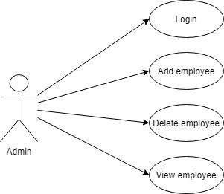

**Use Case Diagram for Admin Staff:**

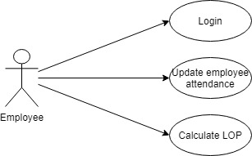

**Use Case Diagram for Employee:**

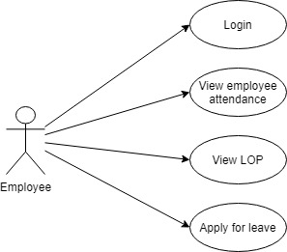

**Sequence Diagram:**

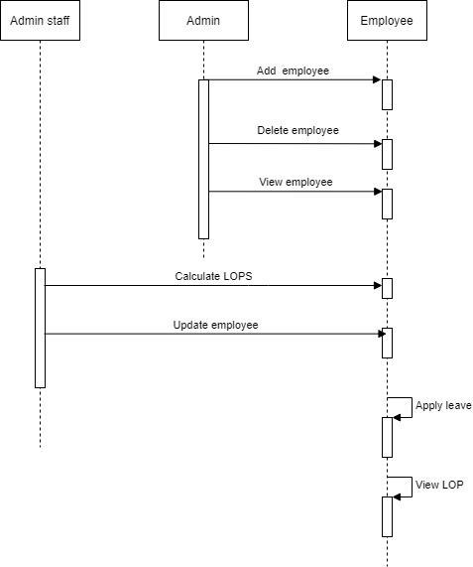

**Activity Diagram For Admin:**

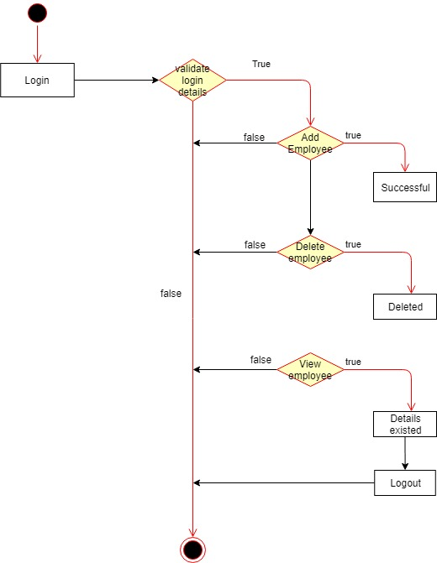

**Activity Diagram For Admin Staff:**

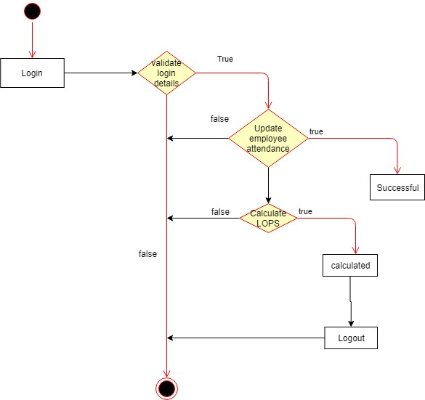

**Activity Diagram For Employee:**

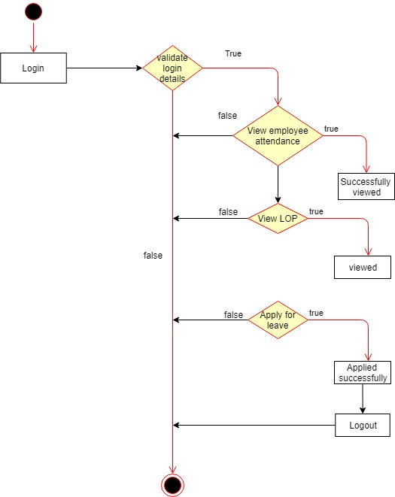

**Flow Chart:**

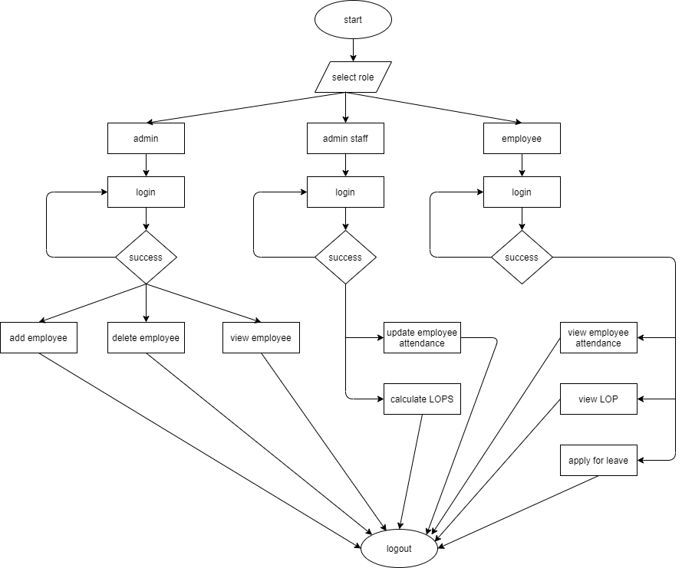

**In Scope:**

* Admin can only add, delete, view employees only
* Admin Staff can only update no of leaves and calculate LOP
* Employee can only view attendance (i.e. the days he applied for leave), view lop and apply for leave.
* Employee can apply for leave till -5.

**Out Scope:**

* Admin cannot update the details of employees.
* Admin Staff cannot see details of employees.
* Approval of leaves are not done once the leaves are applied.

**Sample Screenshots:**

